Embeddable Web Servers
Web servers that are inherently designed for low power embedded systems. We call them embeddable web servers. The protocol HTTP works on a client server model. A client sends a request to a server and the server responds. Therefore, web servers are applications that accept, read and respond to the HTTP requests from clients.
One of the principles of a web server is that it's always responds to a request. The response can be some information that the user requested or an error message. But the server will respond.
We will look into web servers designed for lightweight use. When you are on your computer and you want to access the web, you open a browser and type the URL of the web server that you want to access. Similarly, if you want your embedded device or sensor to access the web, you don't need a web server. All you need is a small client that can send and receive HTTP requests. Simple enough. But what if someone else on the web wants to access your embedded device or sensor? Then you will need a web server.
Resource Heavy WebServers
– Apache
– Nginx.
But we are looking for web servers that will run on devices with a few megabytes, even kilobytes, of RAM and with very limited processing power. Web servers that are small enough that you can execute them as part of your standard application code. We will look into two of these small, lightweight web servers:
– SMEWS (Smart and Mobile Embedded Web Server)
– Mongoose.
SMEWS
It is developed by researchers from Lille 1 University in France. It can run on devices with as low as 200 bytes of RAM and 8 kilobytes of flash memory. It supports multiple connections and doesn't require any operating system to be installed in the system. It has its own TCP/IP stack. This web server comes as a very compact and complete package.
Mongoose
It's open source and free for non-commercial use. Mongoose is more advanced and also heavier than SMEWS. We have tested an implementation of Mongoose in our lab and it was able to handle up to 2,000 clients and 1 million request in total on our test set up. To show you how to use an embeddable web server in your application, we will use Mongoose.

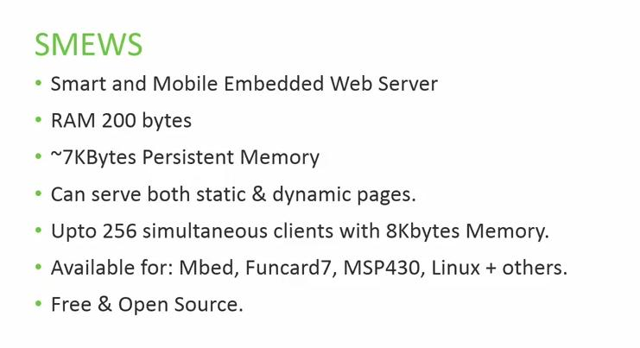 | 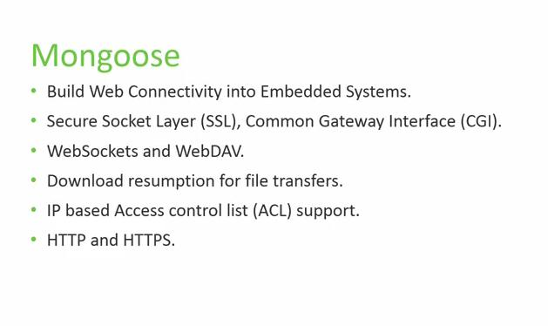

Case Study
Let's look at an example scenario. Imagine you have a temperature sensor whose value you would like to access via your browser. We will not go into too much detail but we'll only explore the basic functions that we need to implement the scenario we just defined. First of all, include the Mongoose header file into your C program. Next we will use a function from the Mongoose API or application programming interface, that enables us to handle incoming requests. In this function, we will specify what happens when a user access a specific URL or uniform resource locator. If you look at the line number 10, we have defined that if the access URI or uniform resource identifier is /TEMP, the program should take three actions. Call a function to check the temperature, send the temperature back and close the connection. The last step is to build the main function and call the web server. How that is done is shown on the screen. And that's it. In three simple functions you can make your applications or devices respond to HTTP requests. Now as a last step in this example, if you go to any browser and type the URL, you will get the temperature as text.
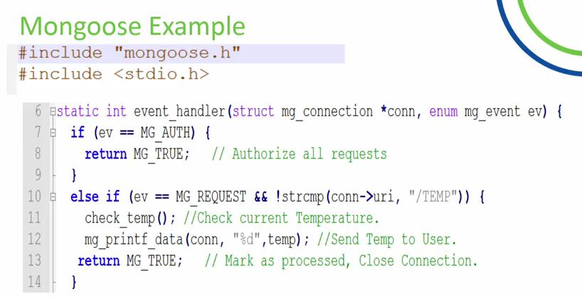 | 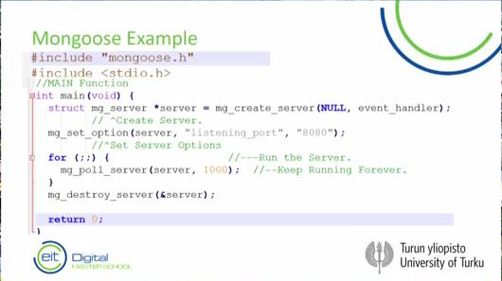

Mongoose Web-Server API Documentation:
https://docs.cesanta.com/mongoose/master/
https://github.com/cesanta/mongoose

